Documenting RESTful APIs

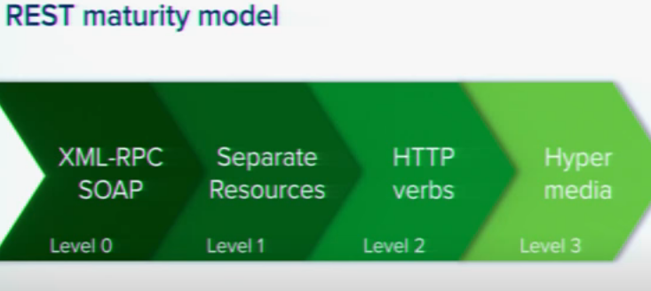

At level 3 : start using Link.

Making Your API easy to document

Consistency: HTTP status codes, HTTP verbs

Uniqueness: Use Distinct relations on your links

